Chapter 8, Problem 55.

For the circuit in Fig. 8.101, find v(t) for t > 0. Assume that v(0⁺) = 4 V and
i(0⁺) = 2 A.
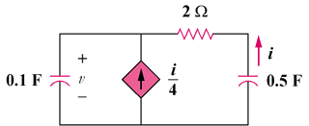

500 mF

100 mF

Figure 8.101
For Prob. 8.55.

